5 reasons to purchase product recall insurance

The decision not to purchase product recall coverage can have devastating repercussions
JUL 15, 2014 | BY FLORIAN BEERLI
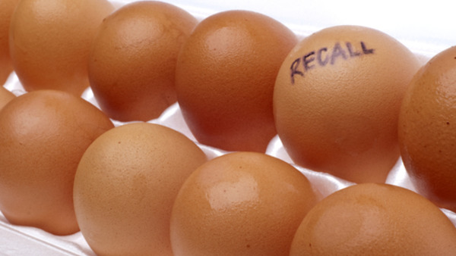
The risk of a product recall has increased exponentially in recent years. Global regulatory standards have increased in number and new product safety rules are implemented constantly.
These developments are positive for consumers, but for companies they produce more stringent product quality obligations. This challenge is greater today than ever before, as supply chains are geographically widespread and manufacturing protocols and standards are not synchronized on a global basis.
Human error being what it is, mistakes inevitably will occur. While most large organizations purchase product recall insurance, many other businesses do not. Based on current developments, and the benefit that this product provides to insureds, we believe that a decision not to purchase product recall coverage can have devastating repercussions.
Product recall insurance is a unique policy that reimburses insureds for financial losses they sustain when it is likely that its product may be recalled. The coverage “trigger” under a product recall policy for a food and beverage company, for instance, would be the knowledge that an accidentally or maliciously contaminated product could cause bodily injury were it consumed by the public. Even if the product results in a finding of no liability, the insured is reimbursed for certain financial costs related to the incident.
How important is product recall insurance? Simply put, many companies can be forced into bankruptcy because they did not have product recall cover. While many large organizations have the resources to address the impact of a product recall, most organizations simply cannot absorb the related financial loss and frequently fail from the consequences.
For corporate risk managers, there are five critical factors which should be analyzed when considering the risk of a product recall event. Read on to see if you should consider selecting comprehensive product recall insurance coverage.
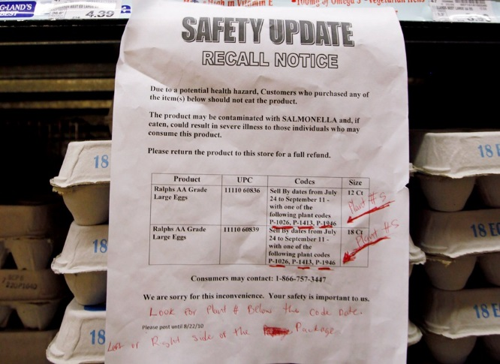
Product recall events happen almost every day.
Rarely does a day pass without news of a company’s goods being recalled for safety or illness reasons. The Food and Drug Administration (FDA) alone recalled 9,469 products in 4,075 separate product recall events in 2012, the highest total in history.
Product safety problems can be caused by manufacturing overseas in countries that do not have the same standards and enforcement as the European Union (EU) and U.S., which explains in part why product recall events are growing. Other factors include the globalization of supply chains and stricter product safety rules and regulations.
Governmental oversight is stronger than ever.
Few dispute the need for strong regulations mandating the highest standards of product safety and security, as the health and well-being of the consuming public depends on these standards. The Consumer Product Safety Improvement Act of 2008 and the Food Safety Modernization Act of 2011 are two examples of how the U.S. government has implemented stringent product safety protocols. While new rules put in practice in both the U.S. and the EU move to keep consumers safe, they also raise the bar for product standards.
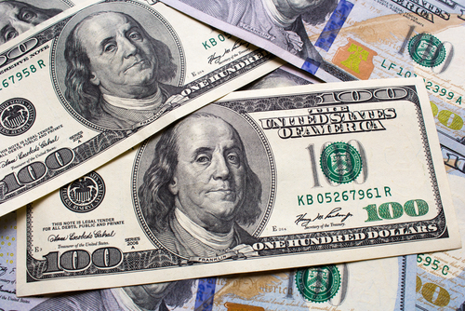
The costs for a recall are prohibitive.
The recall of a product sets in motion a series of events which may involve significant expense. The expenses begin to mount with the cost of pulling the item out of the stream of commerce. In many cases, products must be removed, destroyed, disposed of, and then replaced. In addition, media relations specialists are often retained in order to communicate the details of the recall to the public as well as lawyers and/or government affairs professionals who interact with the relevant government agency.
It is not uncommon for many companies today to endure product recall costs in excess of millions of dollars. In extreme cases, entire industries can suffer from a single company’s product recall. This is the case with the 2010 recall of more than 500 million shell eggs distributed by an egg producer. About 2,500 illnesses were associated with the contaminated eggs, and the adverse media attention produced a drop in egg prices that cost the egg industry more than $100 million in lost income opportunity in September 2010 alone.
The common, very mistaken belief that “it won’t happen to our company.”
Despite considerable evidence demonstrating the likelihood and costliness of a recall, many companies underestimate the likelihood and the degree of the financial consequences. This belief can result in insufficient preparation for the potential crisis and an ineffective response to it.
As we have seen from the volume of recalls which are routinely announced in the public media, no organization is immune to the risk of a product recall—even those with the best safety records, manufacturing and operational controls. A significant reason is human error. Yet, many companies simply deny the possibility that human error will affect the quality of the goods they manufacture.
In my experience, I have seen that there is a tendency, particularly among companies who put products into the global stream of commerce, to downplay the risk. No one is arguing that companies lack the expertise and skill to make and market great products: What is lacking is the knowledge of how to recall a product to limit the financial brand repercussions and the important role played by insurance.
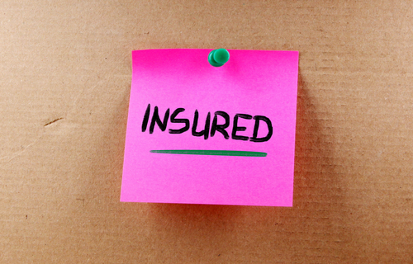
Product Recall cover can be customized to fit the client’s needs.
Generally, organizations can select from three different types of policies, based on the types of products manufactured. These policies include consumable products, such as food, beverages or pharmaceuticals where coverage could be triggered by an accidental contamination; consumer goods, such as finished household products where coverage could be triggered by knowledge the product is defective; and component parts, non-consumable merchandise where coverage could be triggered by bodily injury, property damage or imminent danger of injury or damage. Product recall insurance indemnifies the insured for certain financial losses produced by the insured event. These include the actual physical recall expenses, as well as loss of profit, product replacement costs, extra expenses, and rehabilitation expenses.
The risk of a product recall occurring is substantial, and such an event can significantly affect both a business’ balance sheet and its reputation. The premium cost for product recall insurance is a worthwhile expense as a cost of doing business that may protect a company from financial ruin.
One of the worst things that a company can do is stick its head in the sand and think, “This will never happen to us.” Chances are, it may.

